# AMK Hospital Visitor Triage Program - Fields for Application



|  |  |  |  |  |  |  |  |
| --- | --- | --- | --- | --- | --- | --- | --- |
| **Table 1.1 Login Window** | | | | | | | |
| **Name** | **UI Element Type** | **Size** | **Mandatory?** | **Default** | **Format** | **Validation** | **Error Message** |
| Username | Textbox | - | Y | - | Varchar | TBC | TBC |
| Password | Textbox | - | Y | - | Varchar | TBC | TBC |
| Enter | Button | - | - | - | - | - | - |
|  |  |  |  |  |  |  |  |



|  |  |  |  |  |  |  |  |
| --- | --- | --- | --- | --- | --- | --- | --- |
| **Table 1.2 Administration User Main Window** | | | | | | | |
| **Name** | **UI Element Type** | **Size** | **Mandatory?** | **Default** | **Format** | **Validation** | **Error Message** |
| Visitor for patient | Label | - | - | - | - | - | - |
| Visitor for other purposes | Label | - | - | - | - | - | - |
| Reports | Label | - | - | - | - | - | - |
| User Administration | Label | - | - | - | - | - | - |
| Countries Administration | Label | - | - | - | - | - | - |
| Symptoms Administration | Label | - | - | - | - | - | - |
| Exit Program | Label | - | - | - | - | - | - |



|  |  |  |  |  |  |  |  |
| --- | --- | --- | --- | --- | --- | --- | --- |
| **Table 1.2 Normal User Main Window** | | | | | | | |
| **Name** | **UI Element Type** | **Size** | **Mandatory?** | **Default** | **Format** | **Validation** | **Error Message** |
| Visitor for patient | Label | - | - | - | - | - | - |
| Visitor for other purposes | Label | - | - | - | - | - | - |
| Exit Program | Label | - | - | - | - | - | - |



|  |  |  |  |  |  |  |  |
| --- | --- | --- | --- | --- | --- | --- | --- |
| **Table 1.3 Normal User (Visitor for patient) Window** | | | | | | | |
| **Name** | **UI Element Type** | **Size** | **Mandatory?** | **Default** | **Format** | **Validation** | **Error Message** |
| Visitor for patient | Label | - | - | - | - | - | - |
| Visitor for other purposes | Label | - | - | - | - | - | - |
| Exit Program | Label | - | - | - | - | - | - |



|  |  |  |  |  |  |  |  |
| --- | --- | --- | --- | --- | --- | --- | --- |
| **Table 1.4 Normal User (Visitor for other purposes) Window** | | | | | | | |
| **Name** | **UI Element Type** | **Size** | **Mandatory?** | **Default** | **Format** | **Validation** | **Error Message** |
| Visitor for patient | Label | - | - | - | - | - | - |
| Visitor for other purposes | Label | - | - | - | - | - | - |
| Exit Program | Label | - | - | - | - | - | - |



|  |  |  |  |  |  |  |  |
| --- | --- | --- | --- | --- | --- | --- | --- |
| **Table 1.5 Normal User (Visitor for patient) Window** | | | | | | | |
| **Name** | **UI Element Type** | **Size** | **Mandatory?** | **Default** | **Format** | **Validation** | **Error Message** |
| **Patient Information** | | | | | | | |
| Patient Name | Dropdown | - | TBC | - | Varchar | TBC | TBC |
| NRIC | Textbox | - | TBC | - | Varchar | TBC | TBC |
| Ward | Textbox | - | TBC | - | Varchar | TBC | TBC |
| Bed | Dropdown | - | TBC | - | Varchar | TBC | TBC |
| Adm Date/Time | Textbox | - | TBC | - | Varchar | TBC | TBC |
| Disc Date/Time | Textbox | - | TBC | - | Varchar | TBC | TBC |
| **Searching Visitor by NRIC** | | | | | | | |
| Visitor’s NRIC | Textbox | - | TBC | - | Varchar | TBC | TBC |
| Search | Button | - | - | - | - | - | - |
| List of Visitors | Textbox | - | - | - | Varchar | - | TBC |
| **Visitor Information** | | | | | | | |
| Visitor’s Name | Textbox | - | TBC | - | Varchar | TBC | TBC |
| NRIC | Textbox | - | TBC | - | Varchar | TBC | TBC |
| Contact No. | Textbox | - | TBC | - | Integer | TBC | TBC |
| Temperature | Textbox | - | TBC | - | Integer | TBC | TBC |
| No Fever [ < 30 deg] | Checkbox | - | TBC | - | - | TBC | TBC |
| Time | Textbox | - | TBC | - | Time | TBC | TBC |
| Symptom – dynamic portion | Checkbox | - | TBC | - | - | TBC | TBC |
| Countries Travelled For The Past 2 Weeks – dynamic portion | Checkbox | - | TBC | - | - | TBC | TBC |
| Other Countries | Textbox | - | TBC | - | - | TBC | TBC |
| Remarks | Textbox | - | TBC | - | - | TBC | TBC |
| Do you have any close contact with person or persons returning from INFLUENZA [FLU] INFECTED countries? – dynamic portion | Radio Button | - | TBC | - | - | TBC | TBC |
| Delete | Button | - | - | - | - | - | - |
| New Visitor | Button | - | - | - | - | - | - |
| Save Data | Button | - | - | - | - | - | - |



|  |  |  |  |  |  |  |  |
| --- | --- | --- | --- | --- | --- | --- | --- |
| **Table 1.6 Normal User (Visitor for other purposes) Window** | | | | | | | |
| **Name** | **UI Element Type** | **Size** | **Mandatory?** | **Default** | **Format** | **Validation** | **Error Message** |
| **Searching Visitor by NRIC** | | | | | | | |
| Visitor’s NRIC | Textbox | - | TBC | - | Varchar | TBC | TBC |
| Search | Button | - | - | - | - | - | - |
| List of Visitors | Textbox | - | - | - | Varchar | - | TBC |
| **Visitor Information** | | | | | | | |
| Visitor’s Name | Textbox | - | TBC | - | Varchar | TBC | TBC |
| NRIC | Textbox | - | TBC | - | Varchar | TBC | TBC |
| Contact No. | Textbox | - | TBC | - | Integer | TBC | TBC |
| Location | Dropdown | - | TBC | - | Varchar | TBC | TBC |
| Temperature | Textbox | - | TBC | - | Integer | TBC | TBC |
| No Fever [ < 30 deg] | Checkbox | - | TBC | - | - | TBC | TBC |
| Time | Textbox | - | TBC | - | Time | TBC | TBC |
| Symptom – dynamic portion | Checkbox | - | TBC | - | - | TBC | TBC |
| Do you have any close contact with person or persons returning from INFLUENZA [FLU] INFECTED countries? – dynamic portion | Radio Button | - | TBC | - | - | TBC | TBC |
| Countries Travelled For The Past 2 Weeks – dynamic portion | Checkbox | - | TBC | - | - | TBC | TBC |
| Other Countries | Textbox | - | TBC | - | - | TBC | TBC |
| Remarks | Textbox | - | TBC | - | - | TBC | TBC |
| Ambulance No. | Textbox | - | TBC | - | - | TBC | TBC |
| Delete | Button | - | - | - | - | - | - |
| New Visitor | Button | - | - | - | - | - | - |
| Save Data | Button | - | - | - | - | - | - |

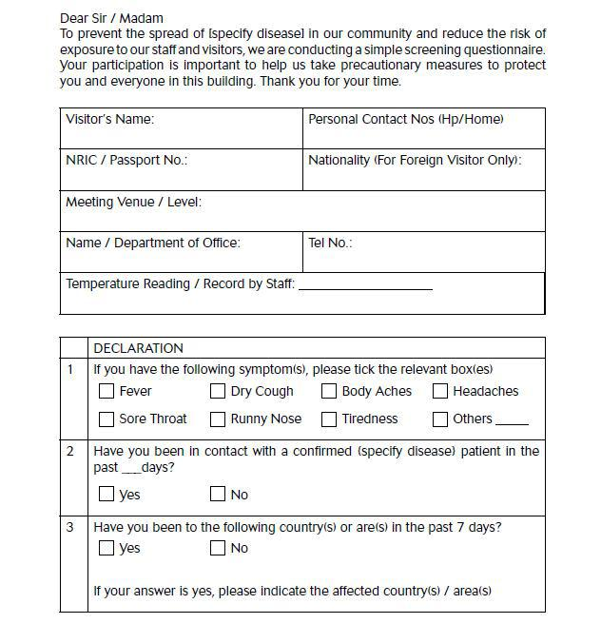

|  |  |  |  |  |  |  |  |
| --- | --- | --- | --- | --- | --- | --- | --- |
| **Table 1.7 Questionnaire** | | | | | | | |
| **Name** | **UI Element Type** | **Size** | **Mandatory?** | **Default** | **Format** | **Validation** | **Error Message** |
| **Searching Visitor by NRIC** | | | | | | | |
| Visitor’s Name | Textbox | - | TBC | - | Varchar | TBC | TBC |
| Personal Contact Nos (Hp/Home) | Textbox | - | TBC | - | Integer | TBC | TBC |
| NRIC / Passport Number | Textbox | - | TBC | - | Varchar | TBC | TBC |
| Nationality (For Foreign Visitor Only) | Textbox | - | TBC | - | Varchar | TBC | TBC |
| Meeting Venue / Level | Textbox | - | TBC | - | Varchar | TBC | TBC |
| Name / Department of Office | Textbox | - | TBC | - | Varchar | TBC | TBC |
| Tel No | Textbox | - | TBC | - | Integer | TBC | TBC |
| Temperature Reading / Record by Staff | Textbox | - | TBC | - | Integer | TBC | TBC |
| **Declaration** | | | | | | | |
| If you have the following symptom(s), please tick the relevant box(es) | Textbox | - | TBC | - | Varchar | TBC | TBC |
| Have you been in contact with a confirmed (specify disease) patient in the past ___ days? | Textbox | - | TBC | - | Varchar | TBC | TBC |
| Have you been .to the following country(s) or are(s) in the past 7 days?  If the answer is yes, please indicate the affected country(s) / area(s) | Textbox | - | TBC | - | Varchar | TBC | TBC |